**39)**

**Aim:** To Design DFA using simulator to accept the string the end with abc over set {a,b,c) W= abbaababc.

**Diagram:**

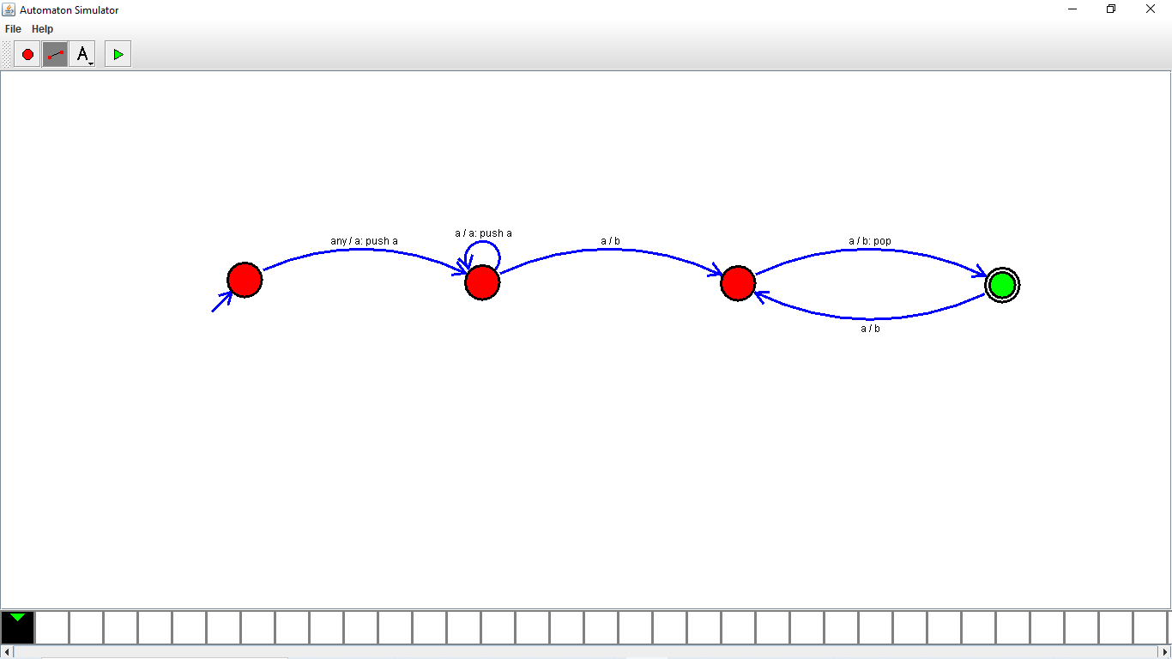

**Result:**

Thus, successfully executed DFA using simulator to accept the string the end with abc over set {a,b,c) W= abbaababc.